

Dr. Jared, Jenkins inc.

2015-12-26

Dr. Jenkins

PSC 5031, Box 0142, APO AE 89111

Phone: 9122621558

Fax: 1681052605

**Re:** Olivia, Jones

**PHN:** 8105142297

**Birthdate:** 21-Aug-1952

**Address:** 551 Garcia Valley, Lake Rebecca, MI 96438

**Patient number:** 4470302403

To Whom It May Concern:

This is a medical letter to state the above patient is pregnant with expected delivery date of 16-Mar-2025. Hoping this information is satisfactory for your requirements.

Thank you.

Sincerely,

Dr. Jared, Jenkins

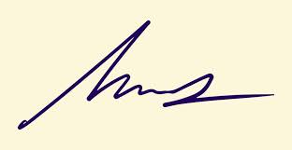

FRCS© NCMP

Clinical Assistant Professor, UBC

Department of Obstetrics and Gynecology SMH